**ASSIGNMENT #1 - Create a Lead Magnet**

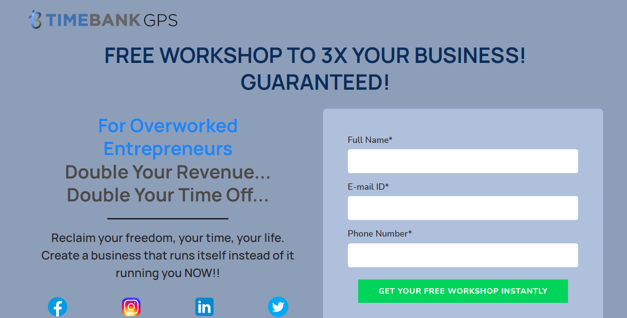

**URL:** <https://app.swipepages.com/preview/63b0edb3f665b10010d14211>